How to set up your computer as a statistician
09/19/2023
11:45-12:45
ARB 532A/B

Speaker: Jeff Goldsmith
Student Panel: Elly Kipkogei, Safiya Sirota, Zining Qi, Tvisha Devavarapu
Moderator: Charly Fowler

Welcome

Presentation by Jeff Goldsmith
2023 notes:
- Latex
  - MacTeX (http://tug.org/mactex/ )
    - LaTeX distribution for Mac users
    - We will have a LaTeX session later in the semester
  - LaTeX (https://www.latex-project.org/get/#tex-distributions)
  - Mathpix (https://mathpix.com/)
    - Formula and text recognition from screenshot
    - easy exporting to LaTeX, MS Word, Markdown, HTML, and PDF.
  - LaTeXiT
    - small utility that allows you to quickly typeset LaTeX equations (https://www.chachatelier.fr/latexit/)
- R/RStudio
- Slack (https://slack.com/)
- Alfred (https://www.alfredapp.com/)
  - App launcher
    - Search/launch application
    - Spotlight indexes everything on your computer, Alfred looks through file and directory names
- Organize your folders and files
  - I.e. organize folders by each year
  - i.e. organize project folder by year_month_collaborator_project
  - i.e. have analysis, data, results, and drafts directories in every project folder
- Make use of workspace/desktop space
  - Magnet (https://magnet.crowdcafe.com/)
    - Reshapes windows on Mac automatically
    - Easier to split screen
- Update software periodically
- Be consistent in organizing things
  - Deciding on a system (and sticking to it) early on will really help
  - Use the same project infrastructure every time
- Get rid of stuff you don’t use to minimize the amount of time spent looking for things.

Panel Introduction (name, program, PC vs Mac, tablet yes/no)
- Elly Kipkogei, 3rd year PhD, PC user, physical notebook for note taking
- Safiya Sirota, 3rd year PhD, PC/Mac user, iPad for note taking
- Zining Qi, 2nd year MS, Mac user,
- Tvisha Devavarapu, 2nd year,MS, Mac user, iPad for note taking

What are some essential softwares to download?
- iCalendar
  - Built-in app on Apple devices, Sync among Mac, iPhone, iPad
  - Useful for planning days, setting reminders
- Notability (h ttps://apps.apple.com/us/app/notability/id360593530)
  - Not free but worth it if you use for class
  - Can copy handwritten math into LaTeX code with premium version
- Overleaf (https://www.overleaf.com/)
  - Web-based LaTeX editor
  - See output as you type
  - Real-time collaboration, version control
  - Good for writing HWs and easy to share through link
- Rainbow Paratheses in R
  - Global Options -> code -> Display -> Rainbow paratheses
- GoodNotes (https://www.goodnotes.com/)
  - Alternatives to Notability
- Notion
- Outlook app on laptop
- Google Calendar
  - Alternatives to iCalendar
  - Easy to organize between PC and iPad/iPhone
  - You can set assignment dues as all-day events
  - Color code events can be helpful
- Google doc/sheet
  - Notetaking for PC and Apple users
- Git/GitHub (https://github.com/)
  - Great for collaborative projects
  - Version control
- SAS studio (Columbia student discount via IT)
- Microsoft OneNote (https://www.onenote.com/)
- Local Latex app
  - Write and click Run, quicker and simpler than Overleaf
- Mathpix (https://mathpix.com/)
  - Can screenshot math on a pdf document, transforms it to LaTeX code
  - Limit on Mathpix for how many pictures you can take
  - Can get around limit by creating a new account
- Stack Exchange (https://stackexchange.com/)
  - Network of question-and-answer websites on topics in diverse fields
  - Online Free question and answer interface

How do you take notes? If by iPad/tablet, can you speak about useful apps for taking notes, annotating a textbook, etc.?
- Notability/Goodnote (mentioned above)
  - Automatically does text conversion, can search for a word in the app
  - Can use it as a notebook
  - Can download and annotate textbooks
  - Can split screen
- CollaNote
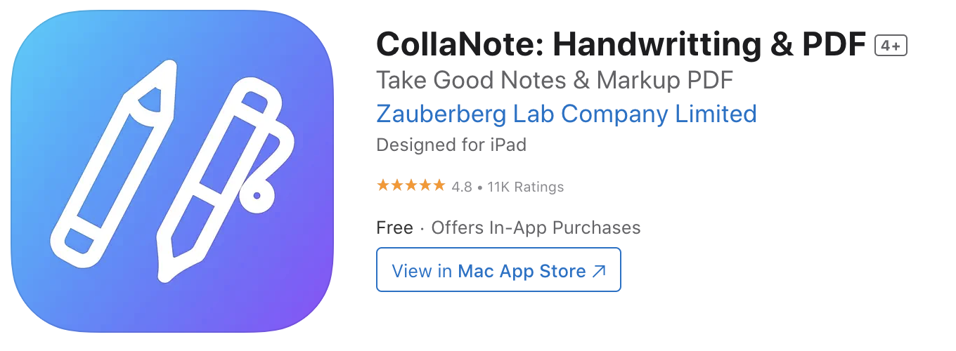
- For non-iPad users:
  - Can keep things organized in Google Drive for classes
  - Print out slides and annotate them during class, keep organized in binder
  - Can use pen and paper and then write up as a LaTeX document later

What advice do you have for organizing files/folders on your computer?
- Focus on consistency and organization for whichever system you use
- Try not to procrastinate with organization because it gets difficult as time goes on
- Standardize directories across courses or projects
- Starting a filename with YYYYMMDD makes chronological sorting easier
- Input assignments and due dates into a Google Sheet to prioritize

How do you keep track of references when writing a paper?
- Zotero (https://www.zotero.org/)
  - Useful for keeping track or references and generating citations in Word
  - Can have a shared reference library for collaboration
- Google Scholar (https://scholar.google.com/)
  - Create an account
  - Allows you to favorite documents and return to them later
  - Can use even when you are not connected to Columbia’s network
- Dropbox (https://www.dropbox.com/)
  - Store refernce papers
- Google Drive (https://www.google.com/drive/)
  - Syncs well between devices and different operating systems

How do you back up files/documents?

One Drive

Google Drive

iCloud

